
Carrera: TECNICATURA UNIVERSITARIA EN PROGRAMACIÓN.
Nombre del alumno: Hotchkyss, Gersom Tomás
Fecha de entrega: 23/8/25

INGLÉS TÉCNICO I
Actividades

- Trabajaremos con este texto para abordar los primeros contenidos de la materia.
.
- La actividad que deberán realizar es la siguiente:

- Trabajar con el texto completando las siguientes premisas, teniendo en cuenta la teoría dada:

1. Identificar los párrafos del texto delimitando los mismos con corchetes. 

2. Identificar las oraciones señalando el inicio y el final con paréntesis. ( )

3. Identifica la oración que define el tema en cada párrafo. Subráyala.

4. Resalta o subraya las palabras estructurales.

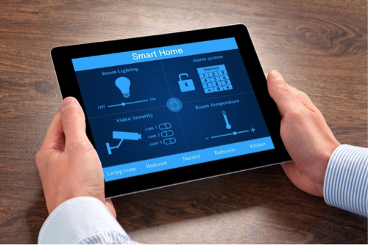

Computers Make the World Smaller and Smarter
[(The ability of tiny computing devices to control complex operations has transformed the way many tasks are performed, ranging from scientific research to producing consumer products.) (Tiny 'computers on a chip' are used in medical equipment, home appliances, cars and toys.) (Workers use handheld computing devices to collect data at a customer site, to generate forms, to control inventory, and to serve as desktop organizers.)]
[(Not only is computing equipment getting smaller, it is getting more sophisticated.) (Computers are part of many machines and devices that once required continual human supervision and control.) (Today, computers in security systems result in safer environments, computers in cars improve energy efficiency, and computers in phones provide features such as call forwarding, call monitoring, and call answering.)]
[(These smart machines are designed to take over some of the basic tasks previously performed by people; by so doing, they make life a little easier and a little more pleasant.) (Smart cards store vital information such as health records, drivers' licenses, bank balances, and so on.) (Smart phones, cars, and appliances with built in computers can be programmed to better meet individual needs.) (A smart house has a built-in monitoring system that can turn lights on and off, open and close windows, operate the oven, and more.)]
[(With small computing devices available for performing smart tasks like cooking dinner, programming the VCR, and controlling the flow of information in an organization, people are able to spend more time doing what they often do best - being creative.) (Computers can help people work more creatively.)]
[(Multimedia systems are known for their educational and entertainment value, which we call 'edutainment'.) (Multimedia combines text with sound, video, animation, and graphics, which greatly enhances the interaction between user and machine and can make information more interesting and appealing to people.) (Expert systems software enables computers to 'think' like experts.) (Medical diagnosis expert systems, for example, can help doctors pinpoint a patient's illness, suggest further tests, and prescribe appropriate drugs.)]
[(Distance learning and videoconferencing are concepts made possible with the use of an electronic classroom or boardroom accessible to people in remote locations.) (Vast databases of information are currently available to users of the Internet, all of whom can send mail messages to each other.) (The information superhighway is designed to significantly expand this interactive connectivity so that people all over the world will have free access to all these resources.)]
[(People power is critical to ensuring that hardware, software, and connectivity are effectively integrated in a socially responsible way.) (People - computer users and computer professionals - are the ones who will decide which hardware, software, and networks endure and how great an impact they will have on our lives.) (Ultimately people power must be exercised to ensure that computers are used not only efficiently but in a socially responsible way.)]
[Adapted from 'Computing in the Information Age', 2nd edition, Nancy Stern & Robert A. Stern, (Wiley), pages 19-22]

